This is your last opportunity for team and individual pictures

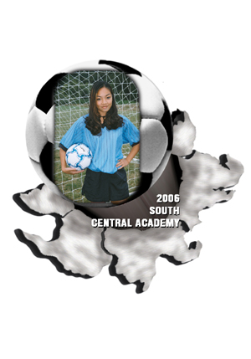FINAL PICTURE DAY IS THIS SATURDAY

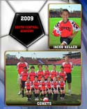OCTOBER 3

Please contact GALLERY PORTRAITURE 816-734-7272 or galleryportraiture@kc.rr.com
to schedule your picture time

Picture orders provide league rebates for RSC and have become a valuable annual fundraiser. Please help support your program.

